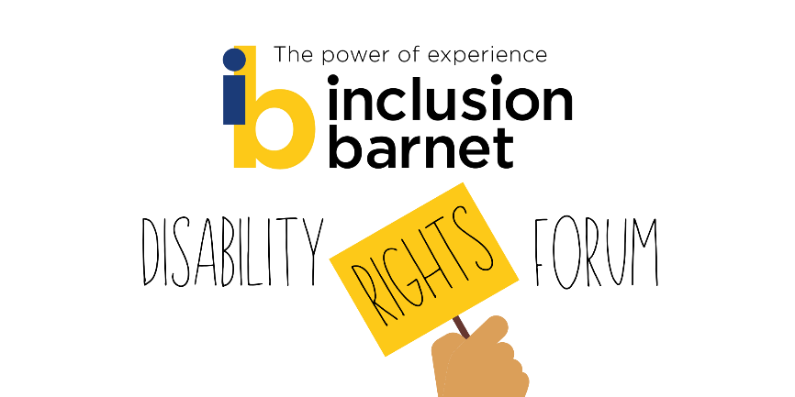

Meeting – 14/12/21

Chair
Eve Byers - User Voice Project Lead, Inclusion Barnet

Scribe
Sam Earle – User Voice Project Officer, Inclusion Barnet

Present
Claire Fisher - Operations and Communications Lead, Inclusion Barnet
Caroline Collier – CEO, Inclusion Barnet
6 IB members and friends

Intro – Eve
Eve: Welcome to Disability Rights Forum meeting. No guest speaker tonight – except Sam introducing the new project! Today’s meeting is for talking about Sam’s project, and to discuss what people want from UV project and as an organization; what kind of audience you want to reach; and how you prefer to be communicated with.

Equivox overview – Sam
Sam: Based on Instagram, Equivox is a campaign aimed at sharing the lived experience of disabled people. The goal is for people to make short videos on their smart phones about a particular area of their experience that they don’t talk about much, and is little understood. We will post these videos on Instagram and across social media and we encourage people to follow the account, and to comment on what they hear. You can contribute by video, text, voice message, in writing. If anyone needs help making a video, we are very happy to arrange a Zoom to go through the details. We will then be analyse the content in order to produce a report with a set of concrete policies/intervention for Barnet.
Member 1: Instagram sounds like a downgrade from a dedicated microsite.
Sam: As internet is jam packed with information, content on a microsite is doomed not to be seen. On Instagram, there are millions of users already there, already disabled people using it for similar issues, it will be far easier to both attract followers and contributors and for the content to be seen and shared more easily. Also, we still have the microsite, and can use that as a repository as well.

Eve: We struggled to recruit people to the community reporters project, because people did not know what it was, and also many people do not identify as disabled.
Member 1: What about TikTok?
Sam: We have considered TikTok – and it is a good option video. We decided on Instragram because we know it better and there are established disabled communities on it. But we can also use TikTok (depending on uptake and capacity. We spoke to a communications expert, who is herself a disabled Social Media influencer – especially on Instagram, and she advised us that Instagram would work well and that there would be a lot of appetite for such a project.

Q&A – Eve

Eve – Running a quick poll to gauge social media use:
- Which of these social media platforms do you use?
Facebook/Twitter/Instagram/TikTok/LinkedIn/None of these
Twitter | 6
Facebook | 5
Instagram | 5
LinkedIn | 2
TikTok | 0

- Do you have conversations on social media about your lived experience of disability?

Yes | 5
No | 4

Member 1: What about You Tube? (comment in chat from Member 3: You Tube would be great).
Eve: Yes, we are exploring that, we want to use the platforms that are already in use.
Eve: I’d like to have a broad discussion about how people communicate their lived experience and how people would like engage. Any thoughts on how you use those social media platforms (mentioned above)? Do people enjoy engaging in online forums? Are there other ways you’d live to be engaged with?
Member 1: Is the alternative physical meetings? Any alternatives? Like email or chat.
Eve: More casual like chats and comments is better sometimes, because it is less time consuming and easier to use. Though moderating online spaces is important. (Sam comments in chat: What about a WhatsApp group? Member 3 comments in chat: that would be good)
Member 1: I’m not a big SM user. I use Instagram but as a watcher not contributor.
Eve: Does anyone have any thoughts about how to engage people on local issues? Are there specific ways on interacting that would be more effective or preferable?
Member 1: To what extent does IB lobby for change at a governmental level? Mind have a template letter for MPs on particular issues.
Eve: This is something we have been talking about doing. Caroline works with Disability Benefits Consortium – lobbying. We are looking at different avenues to explore.
Caroline: Yes we do do that, and are thinking about how we can operate more broadly, but so far, being a small charity, that is not where our focus has been.
Caroline: What changes would you like to see in Barnet?
Member 3: I’m not sure what IB does, I’m new to it. Is there info on the website?
Caroline: We are a DDPO, and not condition–specific, because DDPOs are based on the social model. But DDPOs are a well-kept secret – the public don’t really know about them. We struggle to ensure that we engage and are relevant. We are currently having strategy discussions. Including national conversations, we can campaign for more equitable benefits system. We also have a front-line service, Barnet Voice support group, enablement work, consultancy on how to work with peers, and User Voice, research on adult social care. Supporting local voluntary service. We also deliver Healthwatch Barnet and run 2 libraries.
We do a lot, and we are growing. But know there is work to do in terms of increasing engagement.
Member 3: thanks. Where are you based?
Caroline: The office is in Colindale, also have the libraries, and staff are home-based at the moment
We are very interested to hear about people’ aspirations. If we could build a movement, what would it look like? Where would you like your voice heard?
Member 3: If the organisation will be helpful for people with disabilities, then access to services and Benefits is priority.
Caroline: And any changes locally?
Member 3: I would have to think about
Eve: (shares email address)
Member 1: One long-term issue is integrating DPs into the community, especially in the work environment. Employment is very important – too important – but necessary for status in society, unemployment keeps people out of the issue.
Eve: Agrees, double edged sword. Valuing contribution to economy is sad and dangerous way to value people.
Caroline: Job Centre is doing some work in helping disabled people in to work. Boost service in the council also helps people into employment. I always advocate for more opportunities for how to help disabled get work.
Eve: The recent Barnet Voice survey asked whether there was enough support for getting people into work. Most people felt there was not. People talked movingly about needing to prioritise recovery.
Member 1: I agree on not focusing on employment in monetary terms, but trouble is society recognizes people via their work, which excludes disabled people. But that is a large societal trouble.
Eve: We are realistic in what we can/can’t do - we can’t change capitalism. But we can talk to people and find out what changes can be made at a local level.
Member 3: good to have support for young adults in workplaces. There should be an induction about their needs and accommodations, so that they feel supported. Lot of assumptions are made. People will get offended. It’s a huge barrier that isn’t handled very well in terms of employment. If YAs are assisted it will make their lives much easier. This is something that IB could help with. Could target schools and colleges – with work experience etc. How much do you work with young adults?
Eve: We are very recently starting to work with families of disabled children and young people.
Caroline: Stages is only a 6 month project, to spread the word about how we work. It won’t have the capacity to reach into employment. There is ambition to work with employment issues… but the size of IB is a factor.
Eve: We should normalize having conversations about disability and accommodations, communication styles etc at start of employment. We need to be better at engaging with young adults, which is part of why we are moving into social media
Member 1: A lot of focus on helping young people in general. But the needs of anybody should be looked at, regardless of age. There could be many people who have less work experience than a 21 yr old. There also the issue of exploiting people – low wages and so on.
Eve: Yes, and tricky to balance – hard to find one size fits all solutions. There seem to be more into work opportunities for younger people, rather than getting back into work and so on. Does Caroline know anything about projects about this?
Caroline: ACE project run by Groundwork (but winding down) – think for over 25s out of work for a long time, helping people find placements. Minimum wage to begin with. Trial for work to not effect benefits.
Member 1: Not sure of landscape of opportunities – previously there was Remploy – for hiring DPs. Less funding now, now just helping employability. Initiatives are scaling back due to lack of funding. There’s a general starvation of these projects.
Caroline: many things have been defunded over the last decade. But there’s also change of approach. Remploy ran employment- now the thinking is to get people into the mainstream. Seen as dated model.
Eve: Member 1, is there a specific gap about what information is available for DPS getting work?
Member 1: That would be useful. I think we discussed in a previous meeting – we could include that in DP service index. Advocated policies are the cheaper options!
Eve: Perhaps rationalized by government as providing less intensive support to more people.
We are looking to forge stronger links between UV and Barnet Enfield and Haringey Mental Health Trust (BEH-MHT) etc. What should we do with the info that is given; do people feel they’d like opportunities to speak directly to decision makers, potentially directly? Or is it more useful for us to gather data and act as representatives?

Member 1: Barnet Voice would have opportunities for people to speak to decision makers – for example deputy outreach lead at local trust. I had privilege to meet Mike Freer MP about disability cuts, through template letter sent via Mind. Not sure how impactful it was, but still interesting – yes it is worthwhile.
Eve. We suggested meetings with CCG or Trust previously – not a huge appetite, because people feel they aren’t listened to. How did your meeting with MP come about Member 1?
Member 1: In 2012, in relation to the cuts in benefits. Mind emailed me about sending a letter to MP re the cuts, and this resulted in being invited to Parliament for a 10 minute meeting on cuts and benefit reform.
Eve: We are looking at how we could implement form letter campaigns and monitor the impact of these.
Claire: Hard to find out how successful these campaigns are for small organisations but I have found some tips. Handwritten is better, for example.
Caroline: Not Everyone has had a chance to speak. Member 5, any thoughts?
Member 5: I have been listening, very interesting. Boost is very helpful. Hoping to get into apprenticeship, and welcoming any opportunity to work and learn new skills. I want to achieve goals according to my talents.
Caroline: Excellent, and try ACE that may help with that – link in chat.
Member 5: I’m gathering experience… wanting to learn opportunities. You want to use the skills you’ve learnt over the years.
Eve: If no one has any further comments, thanks very much for joining. Enjoy the festive period and please get in touch with us if you have any thoughts or questions - and do sign up to the newsletter if you haven’t already.

Links and Resources

Boost - BOOST – Employment and Financial support in Barnet . (boostbarnet.org)
ACE - ACE Able Capable Employed - Groundwork

