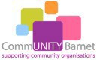
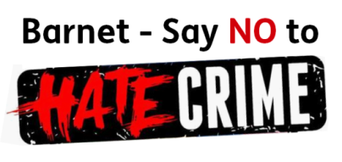

Barnet Hate Crime Awareness Week
11th to 15th October 2021
Visit a Hate Crime Reporting and Information Stand
Sign Up to become a Hate Crime Reporting Champion
Monday 11th October  Finchley Central  10am-1pm  Albert Place, Finchley N3 1XP |  | Wednesday 13th October  Middlesex University  10am-2pm  The Burroughs, London NW4 4BT
Thursday 14th October  Edgware Bus Station  10am-1pm  Station Road, Edgware HA8 7BG |  | Friday 15th October  Golders Green Bus Station  10am-1pm  1 Golders Green Road, NW11 8DY
Barnet Hate Crime Awareness Week 2021
Focuses on Making Barnet a Safe Community
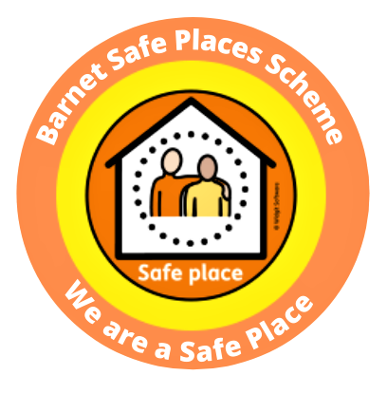 | Visit our stand to join the  Barnet Safe Places Scheme
 | Register to become a SAFE PLACE
Collect your
Hidden Disabilities Sunflower Lanyard

For more information please contact:
Barnet’s Hate Crime Reporting Co-Ordinator, Reshma Hirani at reshma.hirani@barnetmencap.org.uk

