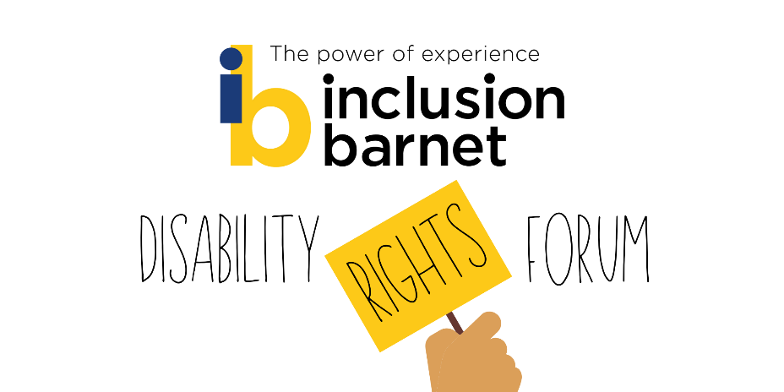

Disability Rights Forum Minutes – 07/07/21

Chair
Eve Byers - User Voice Project Lead, Inclusion Barnet

Scribes
Margaret Smith - Project Assistant, Inclusion Barnet
[for Healthwatch Barnet] Alaa Al-Ansari - Healthwatch Barnet Volunteer, Inclusion Barnet

Present
Caroline Collier – CEO, Inclusion Barnet
Claire Fisher - Operations and Communications Lead, Inclusion Barnet
Jon Abrams – Campaigns Officer - Inclusion London
Judi Dumont-Barter - Voluntary and Community Sector Representation Lead - Inclusion Barnet
Yasmin Rahman - Healthwatch Barnet Peer Research Officer – Inclusion Barnet
4 members and friends

Presentation: #ScrapCareCharging
Jon Abrams, Inclusion London

Jon introduced himself as Campaigns Officer at Inclusion London. Jon spoke at length about the campaign to scrap care charging. He said that local Deaf and Disabled People’s Organisations (DDPOs) play an important role in communities, especially in the wake of Covid which has amplified the problems disabled people experience.
Jon mentioned that Inclusion London supports DDPO’s across London. It supports about 70 organisations of different sizes that provide different services to about 80,000 disabled Londoners and can offer a big voice in campaigning. Issues Inclusion London have campaigned about include welfare reform and the benefits bedroom tax. In a few weeks the government is revealing its draft National Disability strategy which is an opportunity for relevant organisations to comment and get involved.
Jon went on to say that for a few months Inclusion London have been working on a campaign to scrap social care charging. Social care charging is not so widely known about by the general population.
Social care is not free at the point of use. If you have a heart attack for example and have to visit A&E, it is free. By contrast social care can work out quite expensive for people. Under the Care Act local authorities have the discretion to charge people for their care.
Hammersmith and Fulham are the only English local authority not to charge for home care. (Scotland and Wales have different laws and different policies regarding this).
Charges for social care may vary but often people find the charges unaffordable. As a result of not being able to afford social care charges, some people just drop out of social care and go into crisis. Some lose touch with services or local authorities. Others find themselves facing stark choices between paying for food, heating or care. It is a postcode lottery about the price you pay for social care. Despite Covid, councils are increasing charges.
Jon said that parents, carers and groups are coming together and setting up groups to campaign for scrapping social care charging.
A member asked Jon “Can we get more involved in supporting Inclusion London either with yourself or with Inclusion Barnet?”
Jon suggested some ways that individuals could get involved in campaigning on this issue of scrapping the social care charge.
• Jon praised Inclusion Barnet’s tweets about care charging and encouraged campaigners to retweet them.
• He also suggested campaigners write a letter urging Sajid Javid, the Health Secretary to reform care charges. A template for the letter is available.
• Jon also mentioned that you can put pressure on your local council as to how they have responded to the Norfolk Judgement. (see bottom of this page for more information on the Norfolk Judgement).
• Jon also said that it would be a good idea if IB could arrange a meeting with one of the local MPs Matthew Offord as a guest speaker. Jon would certainly attend. Caroline responded that she could look into that, into getting local politics represented at these sorts of events.
Jon discussed the Norfolk judgement. The High Court ruled that in Dec 2020 Norfolk County Council had discriminated against a disabled woman with high support needs. Norfolk Council had to subsequently change its charging policy. In response to the Norfolk Judgement other local authorities are carefully considering their legal position.
A member was interested in whether one could appeal a local authority decision based on the Norfolk Judgement.
One member asked “Does each local authority charge their own amount or is there a set amount laid down in law?”
Jon replied that each local authority has the right to charge within certain guidelines, it is means tested. When you get an increase in benefits, local authority charges increase.
More information about scrapping social care charging is being spread and Jon reckons that this offers a potential opportunity to influence government e.g. the local elections coming up in 2022.
The BBC for example has worked with Inclusion London on 2 programmes about reforming social care. As well, newspapers like the Times and the Telegraph have carried articles about the subject.
Claire asked “Do you have any info about what influenced Hammersmith and Fulham to provide free home care? Is there anything we can learn from that?
Jon commented that Hammersmith and Fulham introduced no charging for social care in 2015. The Council were able to make savings for example in their PR department. They didn’t have to send out a newspaper as a result of scrapping social care charging which allowed them to make savings.
Jon said that if there is reform, it is important that disabled people are put at the heart of reform and their opinions heard.

Your Thoughts on Remote GP Consultations
Yasmin Rahman - Healthwatch Barnet Peer Research Officer
In the next stage of the meeting, Yasmin from Healthwatch Barnet sought to gather feedback from the attendees on remote GP consultations. She said that disabled people have more difficulties than others accessing GP services for example accessibility issues.
Yasmin reported that the NCL CCG (North Central London Clinical Commissioning Group) wants to introduce more digital and remote appointments in the future.
Yasmin and Alaa asked many questions like:
• What has worked well and not so well during the appointments, how have follow ups, prescriptions, referrals to hospitals been?
• Have you had longer waiting times, how have you found the booking system?
• What services would you like to see sent by text or app for example test results?
Eve said that once you submit an e-consultation form, you get to speak to a GP much more quickly than before. However the disadvantage for Eve was the high administrative burden expected of the patient. It took 15 minutes to fill out a form for a simple request for a repeat prescription. It was very time intensive. Eve said that it makes it very difficult for people with chronic or complex conditions to manage the admin side of their healthcare, particularly if they are neurodivergent.
A member said that being able to order repeat prescriptions on an app is a godsend, but wished to highlight a communication problems they thought the NHS were having. They look after their father, son and husband. The member receives texts for appointments, but the texts don’t say which of the 3 people the appointments are for. They have found trying to phone up the relevant service to sort this out a nightmare.
Yasmin and Alaa asked the attendees that if they were satisfied with remote contact with their GP, would they like this to continue in the future? Did they have any suggestions for improvement that would make their experience better?
A member mentioned that her 21 year old autistic son hadn’t had a health check for 2 years and wished to flag this, that GPs should be doing more regular health checks.
The member also said that it was convenient to have online consultation, for example their husband is severely disabled and having online consultations mean that they avoid parking problems.
It was also reported that seeing a GP face to face could be easier for certain conditions for the GP can check the patient.
Another member said that GPs are not reviewing mental health medication and discussing this with the patient as they should be doing annually. They said that they have seen a clear rise in this happening, mental health patients are being forgotten about and Covid has only exacerbated the situation. Patients aren’t having their injections administered for example.
Yasmin asked how easy was the technology to use, for appointments etc?
One member replied that older users like their dad who is in his late 80s would have more problems using the technology. During his online consultations, they have had to be there for their dad, and they have had to use their phone.

Topics for Future Forums
Eve Byers – User Voice Project Lead, Inclusion Barnet
There was next a discussion about what attendees would like to cover at future forums.

A member raised several points:

• They would like to discuss the online Safety Bill which will become law soon. It will remove material that’s harmful or illegal from websites – how does this impact people who have a disability.
• The Hendon Hub consultation and analysing use of the libraries from a disabled person’s perspective.
• Also regarding the White Paper on the revised Mental Health Act, the member believed that IB needs to have some representation in this, IB needs to start campaigning.
• Updates on what’s being done about cladding safety following the Grenfell Tower fire.

Judi reported earlier that she added the issue of cladding to the London Resilience Forum risk register, in the event of catastrophic fires etc.

Caroline ended the meeting by saying that she really appreciates members coming to the event as it’s really valuable for people to have these sorts of consultations.

Links and Resources

Summary of The Norfolk Case regarding Care Charging
Leigh Day, the legal team for SH and her mitigation friend MH, won their case that “The Charging Policy discriminates against severely disabled people, contrary to Article 14 read with Article 1 of Protocol 1 and/or Article 8 of the European Convention on Human Rights”.

Outcomes
Norfolk County Council charging policy has been found to be discriminatory. This has affected approximately 3200 disabled people across Norfolk in receipt of adult social care and resulted in the Council having to pay back approximately £1 million to those affected.

The judgement in full: https://www.bailii.org/ew/cases/EWHC/Admin/2020/3436.html

Inclusion London’s resources on Care Charging, the Norfolk Case and how we can campaign for change: https://www.inclusionlondon.org.uk/campaigns-and-policy/act-now/social-care-charging-campaigning-resources/

