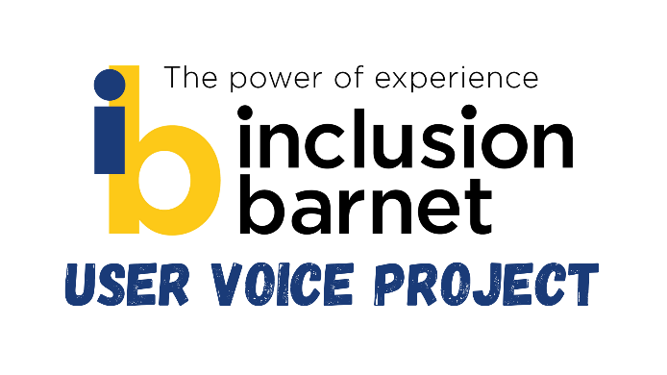
Disability Rights Forum minutes – 31/03/21

#IncreaseLegacy Benefits Campaign - Q&A
Ella Abraham - Z2K and Disability Benefits Consortium

Q: Do you think they will listen to us?
A: I think they’re being forced to, because so many people are saying it to them. The more pressure we can put on the government, the harder it will be for them not to listen. It’s hard for the public to understand so it’s important that we speak up and try to make them understand.

Q: Is speaking out better than keeping it inside? It’s been hard for me for the last year and I’ve kept it all inside, but now I’ve decided to speak out.
Absolutely! It’s really important that individual disabled people are willing to speak out – the government always ask us for evidence. It is so helpful for people to say how they feel, such as through surveys.
If 82% of people tell us that their costs have increased, we can use that to say to the government ‘this is how you’re making us feel’.
There are lots of options for speaking out publicly, such radio, pre-recorded or live TV and having your story written up as a case study. You can participate anonymously or using a different name if you prefer.

Doesn’t it come down to equal rights?
A: We absolutely see it as discrimination.
We have a hopeful legal challenge. Funding has been secured for some individuals to take the challenge forward, and we think it is now going to crown court. We think they will then ask for witness statements from organisations. Have presented initial evidence, will go back with more as next step.

Q: What can I do if I want to tell a specific story?
There are lots of ways to share your story, but I would always urge caution when it comes to approaching journalists directly. It can be better to go through an organisation such as a charity which is focused on the topic you would like to talk about. They can often shield you a little bit from any pressure to give information you don’t want to.

